Lecture 2
Problem:
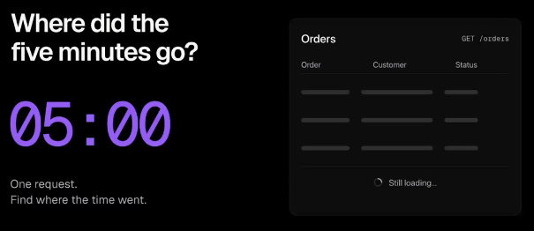
We have a website that has orders table. Till yesterday the API was running in <5 ms now somebody reported that the same API takes lot of time (table/website takes lot of time to render). Now it takes 5 min. What might have happened here.
When such a question is given, do not straightaway ans, ask questions to interviewer. Interviewer will be impressed if we ask good questions.
We must 3 questions in such scenario:
- Configurations: Tell interviewer that I’m assuming the architecture is simple like we have frontend, static pages on CDN, API gateway, reverse proxy, load balancer, server and a database. Ask if this architecture is correct or should we add more?
- Did it happen for certain period or is it still happening?
- Anything that changed:
  - Code Change
  - Seasonal change (Diwali etc)
  - News (Something gone down across globe (ex: amazon services down)
Whenever debugging any problem always go front to back. At first level we can open the browser and check all API calls etc.
If all above 3 has not happened (a, b and c) then lets debug -
>> Can something go wrong in the browser?
The data is coming too quickly that browser is not able to render them. Browser also takes some time to render them. Or browser has some memory issue. May be our computer where we are running has very less space (less RAM left). Or old cache. May be the frontend code has some bug like react component is re rendering.
We can easily see in the network tab how much time is taken by an API. If api takes only 1 sec and the page is loading for a lot of time then we can say it is the browser issue.
On browser side it was easy as we just check the network tab, now on backend side its tricky as things are deployed.
>> Lets proceed forward, if the issue is not at browser
Frontend -> API Gateway -> Reverse Proxy -> Backend -> Database
Every component above can emit following things -
Log: Whenever we pass any request from frontend, we attach a request id with it. As the request goes through, we log it. It can be seen on terminal whenever any packet is sent. (Open terminal and request something on a particular website). We will see at what time our request has reached at which place. On top of these logs, observability tools are built. These are put on cloud watch.
Metric: We can ask each of the server or component to keep metrics. It only gives numbers, doesn’t tell how.
Traces: Where was time spent. If we want to know the usage, we can build traces.
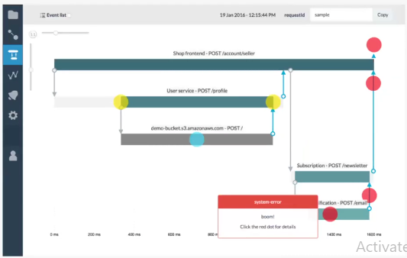
We can build traces from the logs. For a particular API, if we give that request id, then it will tell which service it was using at what time.
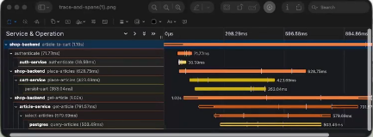
Span:
90% of the companies use grafana. Trace will be for particular request. If we want to see how want times that request is failing, we need to use metric or the grafana dashboard. We can collect metric and plot it in the any tool like grafana.
Now if we have these profiles we can easily figure out, where is the time being spent (which component). Now the only thing that is left is why is this happening (we have to go inside it). This component is our bottleneck.
Things can fail on multiple fronts:
- Latency
- Throughput
- Concurrency
>> API Gateway
Lets pick Gateway. Why can gateway fail?
At gateway, there is chaining of 3 stuffs. Auth, traffic policy/rate limiting and routing. It might be that we are using any external service for above 3 and their service is slow (like google auth can be slow). Auth generally has time limit so 5 min cannot be from auth side. Some API’s can have a rate limit due to which this can happen. Frontend is written in such a way that automatically it is getting reloaded. Since everything was working yesterday, so routing is not possible.
Too many requests: Not possible as this will make every component fail not just api gateway so this option is out.
Suppose there is no issue on API gateway. Now lets proceed.
>> Reverse Proxy <-> Load Balancer
One of our servers has gone bad and we are still directing our packets there. If the server is not responding then we have something call health check.
Reverse proxy and load balancer are synonyms. They do the same kind of work. RP can do lot of work. Load balancer does a very specific stuff/just 1 work. It’s a simpler configuration of RP.
One more thing that can happen is the request is getting rate limited but the browser is constantly sending retry request.
Ques: If API Gateway does the routing then what is reverse proxy actually doing?
Answer: Suppose we have 2 API’s say for leetcode: /submission and /leaderboard. If/leaderboard api is slow then we can have copy of the code on multiple servers again. So API gateway is needed when choosing between API’s and load balancer when choosing among multiple servers of /leaderboard.
>> Backend and database
In real life mostly all problems happen because of these 2 only.
Lets go deeper: what happens when an api call hits the backend server?
- The code is written at application layer. What happens from network layer to application layer: A socket is created by backend. All requests sit in a queue. Our backend code will be run by some process or thread or event loop. For most of the web servers, there will be bunch of workers. These workers pick the job of scheduling the requests of API’s sitting in the queue. It will accept the socket connection. Worker will run that function and it will respond back.
- There will be multiple queues like sync queue, accept queue handled by network stack (NIC). When a http connection is trying to get connected it will send a sync message. Then server will send back the sync/ack request. When an ack is received from the client, the request moved to ack queue. First the request is in sync queue. Now the OS is managing the worker threads, scheduler picks up one-one workers of the backend.
- So something can go wrong in the network stack queues. These queue sizes are configurable parameter. If any of these 2 queues are small and lot of connections are coming then there is network congestion, request can get timed out.
- The number of worker threads are defined by something called thrashing.
- After the OS schedules the request to a thread, execution happens, a db call can be made. And it will reply back after the execution completes with the response to the client.
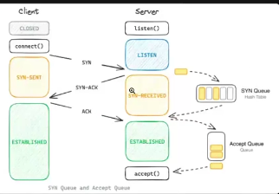

Read: There is 1 more thing that can go wrong in the backend. This is the differentiator between SDE 1 and SDE 2. There is something called as Garbage collection. GC can halt the whole server. Then server will go out of memory. Every process will stop running. GC has taken lot of RAM so nobody is able to do anything but queues are getting filled up. GC can happen anytime, mostly people turn it off.
>> Caching:

When the request goes from backend to database, a TCP request is made. This can be slow too. We can do caching here.
>> Without caching what can we do, how can we make network calls fast between the backend and DB
Can we save number of http connections here?
- Long Lived connection: The worker thread will make the connection with the db once and it will hold that connection till that connection completes so that it can get back the data quickly.
- Connection Pulling: Executors can directly call connection puller and it has long lived connection with the database.
If there is no space left in connection pulling or long lived connection is taking too much time, then also your server will become slow.
On the db side also there will some worker threads accepting the connections. There are some limited number of connection a db can handle. In postgres the default number is some 100, it is a configurable parameter. If all db’s workers are busy backend connection will wait. There are many webservers (it can be scaled), connecting to the database in a long lived connection.
Read about these 2 as well.
Vibe code all these components. Using AI, check can we change the parameters of all queues, Tweak them see how things change. Or build docker compose which has all these parts, try to see how these connections are built.
>> Database
In db, we have following order: connect with http request, execute the sql statement and commit. In db, sql queries get executies in this order
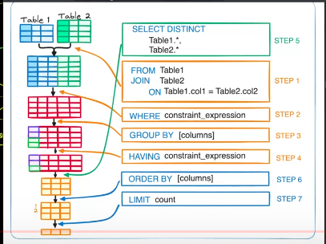
Another issue can be there is no index on table so building an index can fasten up the query. Another thing is row locking. Then db memory has become full.
WAL (write ahead lock): When we are running any transaction, it has to flush wal. Db support ACID properties by doing WAL. Flushing takes lot of time.

